Access Sheridan

Initial Wireframes & Interaction Design

SYST15829 - Interactive

Guided under - Professor Himanshu
Date of Submission: Tuesday, February 18, 2020

Group Members: Daniel Ball, Minh Nguyen,
Nicholas Razack, Xingning Xu and Zawad Hossain

Roles
Daniel Ball (Initial Sketch):
Minh Nguyen (Documentation):
Nicholas Razack (Hierarchy):
Xingnig Xu (Final Sketch):
Zawad Hossain (Wireframe):

Survey Results
The results of the survey we carried out produced the results we were anticipating. Users shared that current Access Sheridan site is outdated and pointed out the following
- Nice login page with less text
- A web page with less text links looks more simplistic.
- A more interactive web page asking for a modern look.

Choosing the Right Color
From the Color Theory we learnt in class, we chose to stick to the base color and use the appropriate tints,tones and shades of the hue to maintain consistency throughout the web site.
For Sheridan College there are two base colors.

From the theory, we will be using the 1st base color and its tints to be the theme (like header, footer, menu etc) and the links/ buttons(when hover/clicked/entered) will be using the 2nd base color.

Choosing the Correct Font
In order to implement the typography rules, we need to first select a font which is perfect for our needs. We are hoping that our web site will have less text and to give it a more interactive look we will convert the links to button type. As there will be less text we should go for a sans serif font like Arial, Tahoma, Verdana or any other fonts within the family.

Initial Sketches
Based on our survey results, we did some initial sketches for our web site and hierarchy
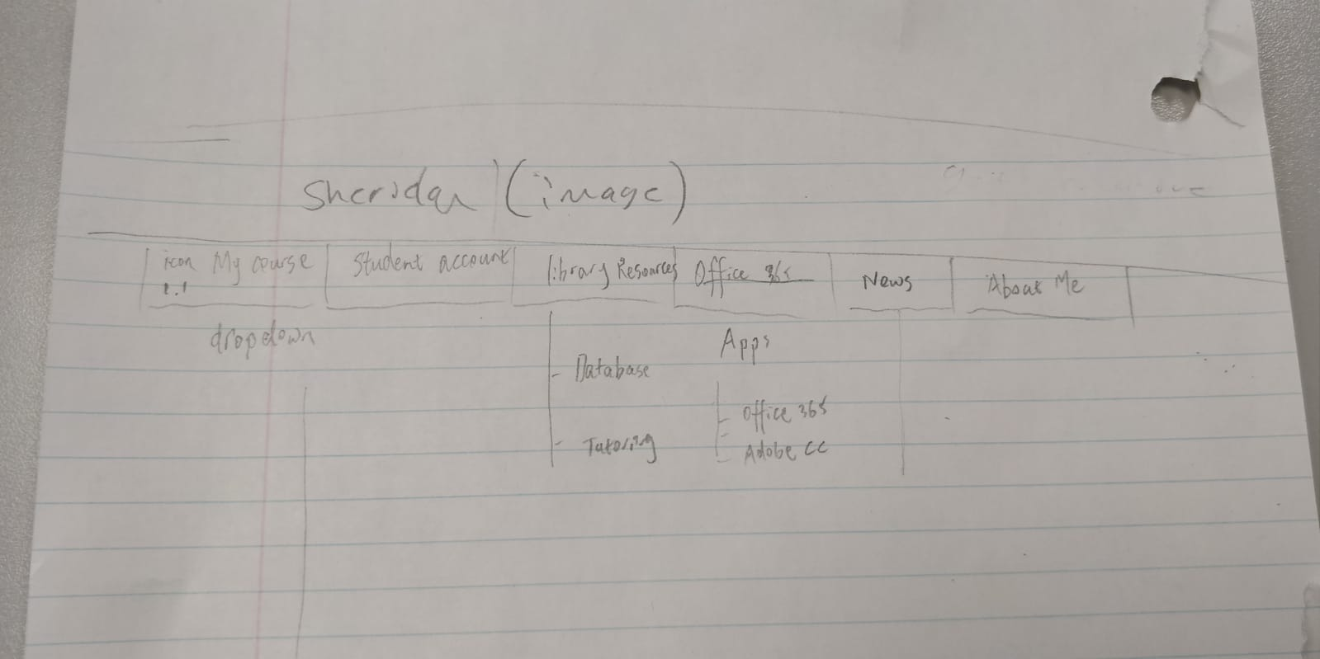
Figure1 : Initial hierarchy of our site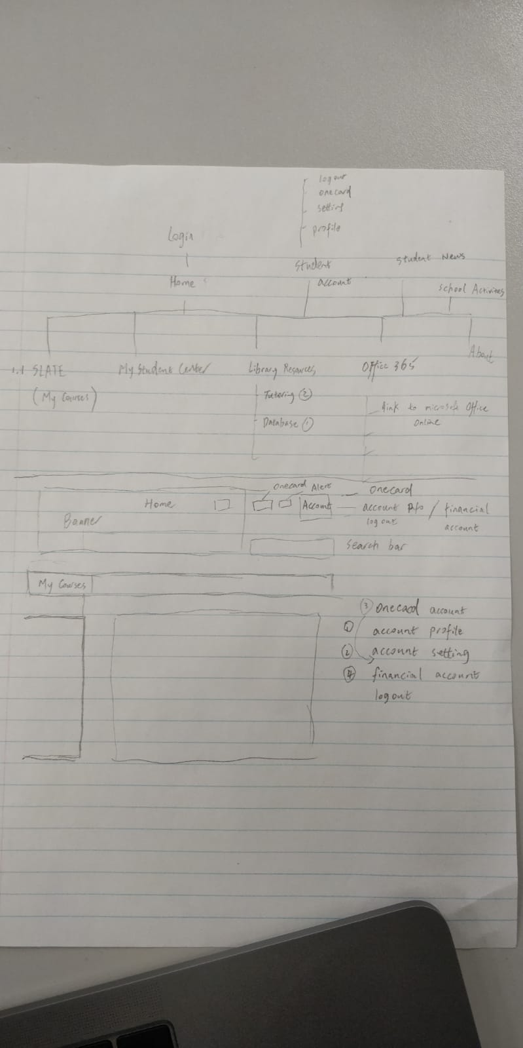
Figure 2: Initial sketch of our landing page

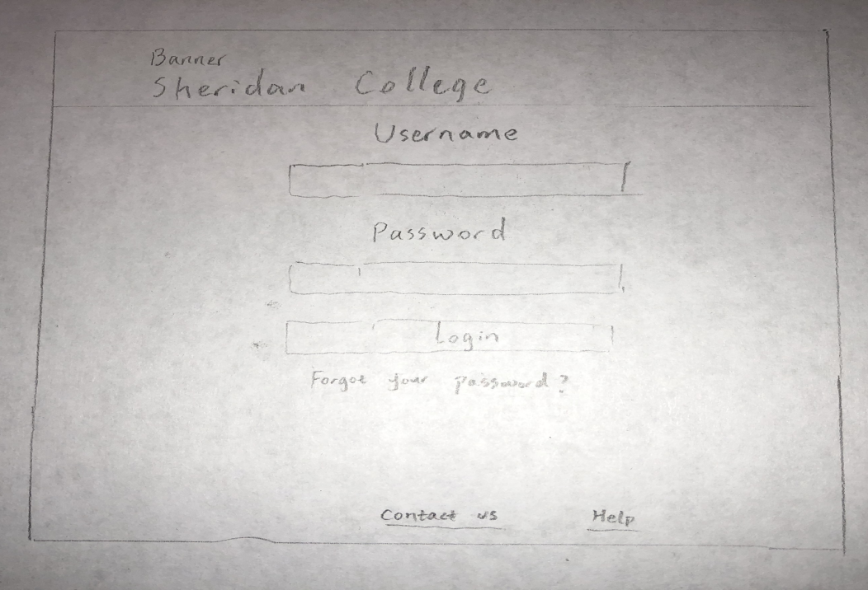
Figure 3: Final sketch for our login page
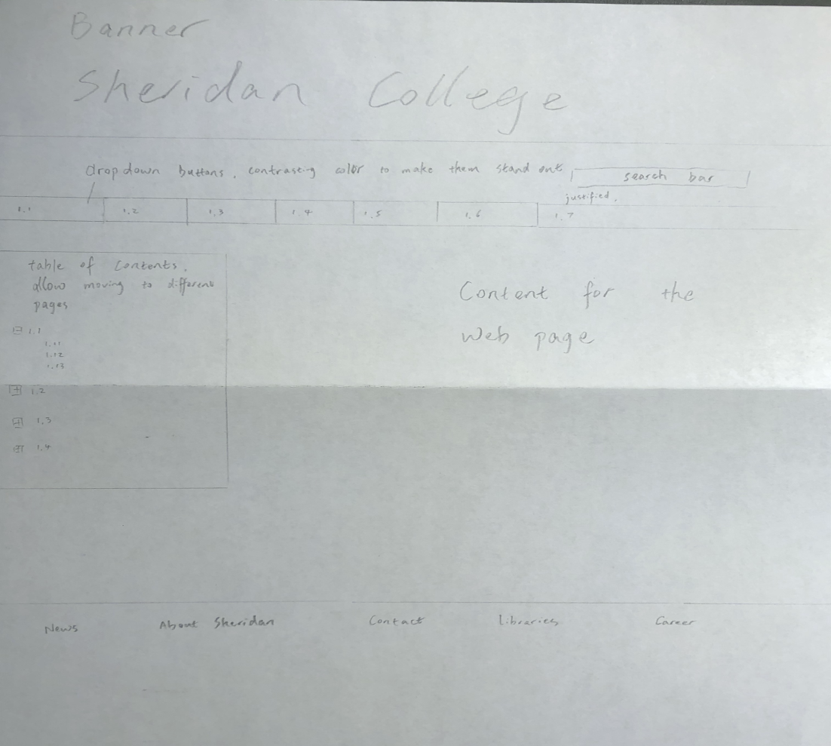
Figure 4: Final sketch for our landing page

Page Hierarchy
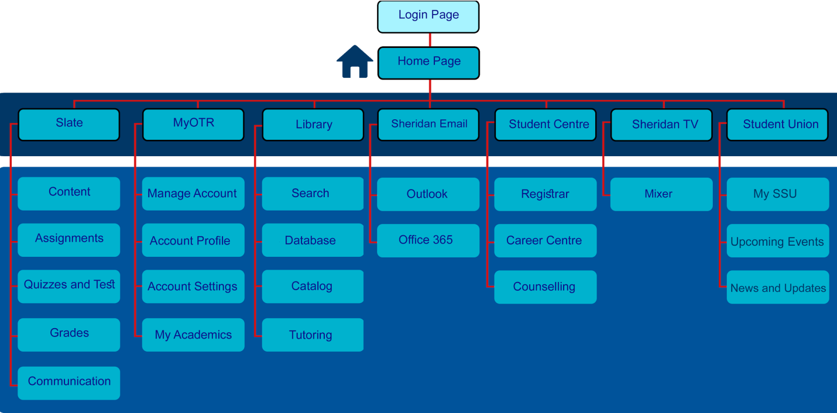
Figure 5 :Final hierarchy of our webpage

Login Page Wireframe
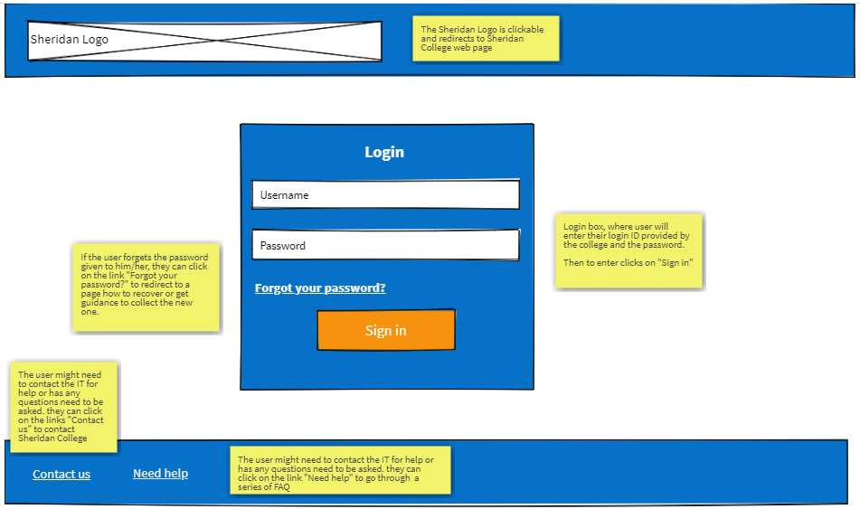
Figure 6: Wire frame for our login page (wireframe pro)

Landing Page Wireframe
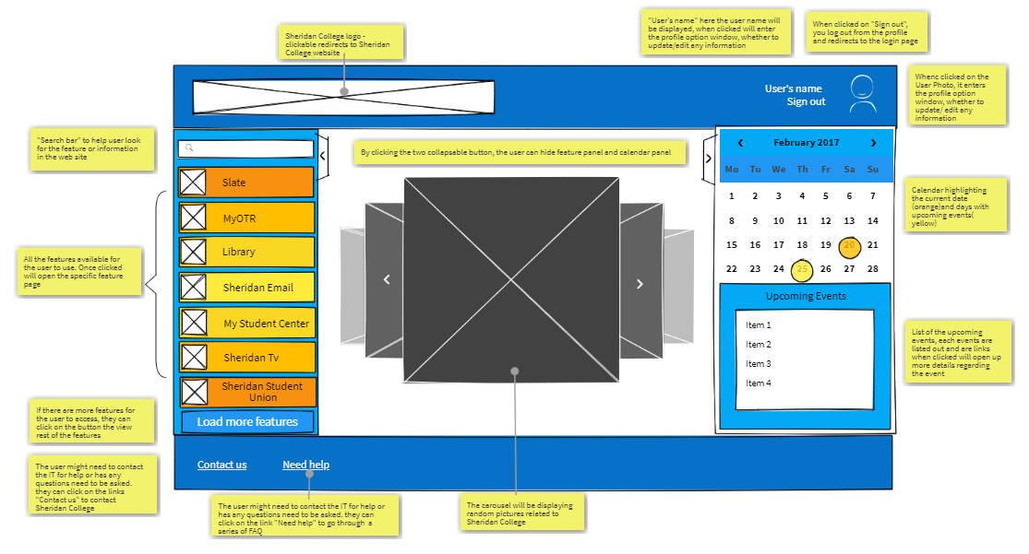
Figure 7: Wire frame for our landing page (wireframe pro)

Subpage Wireframes
- Search Page
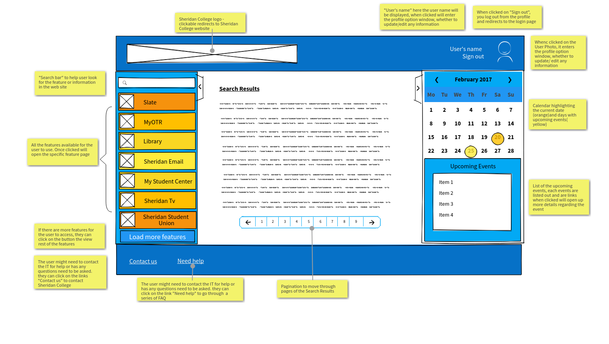
Figure 8: Wire frame for our search result page (wireframe pro)

- Slate Page
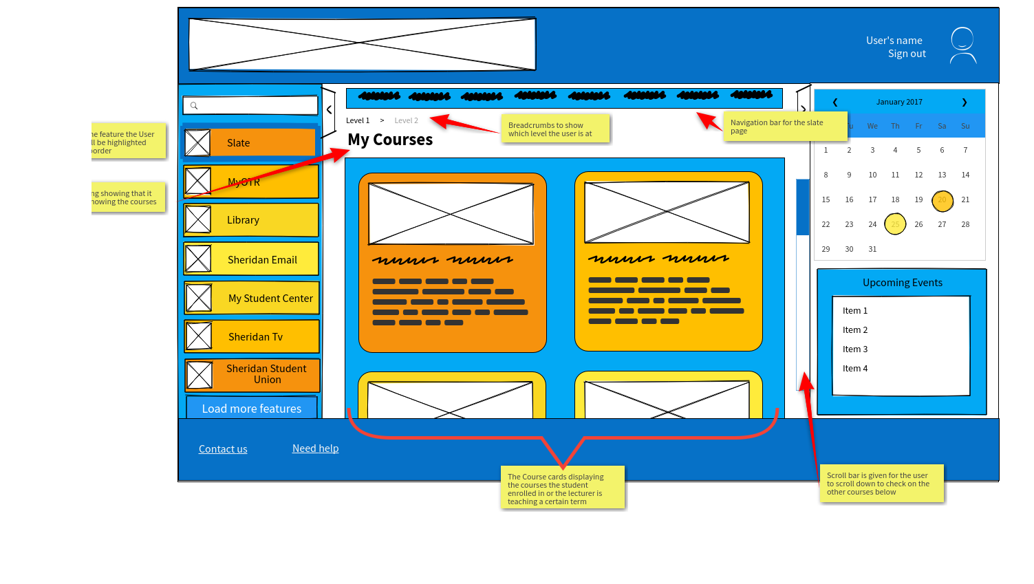
Figure 9: Wire frame for our Slate page (wireframe pro)

- My OTR Page
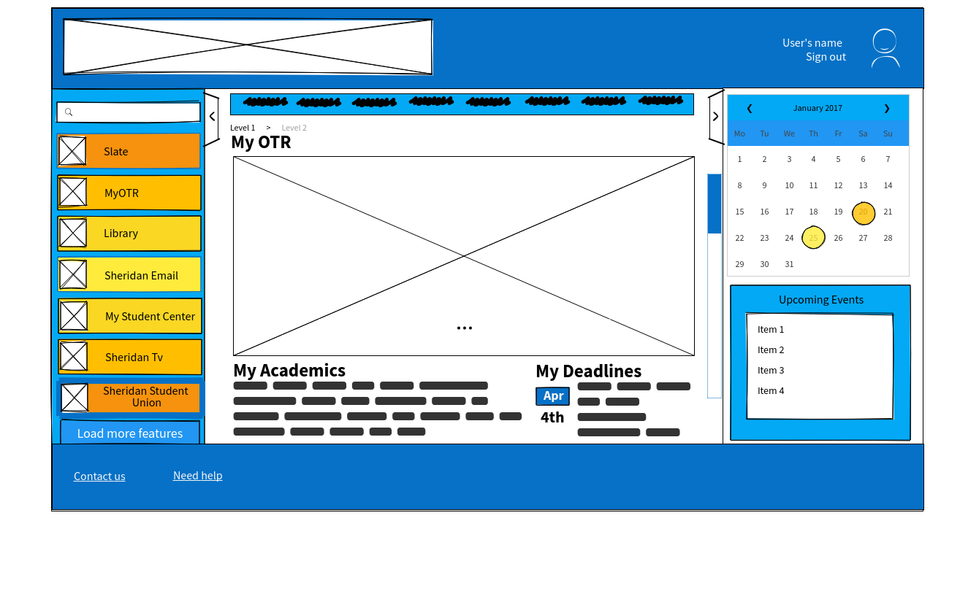
Figure 10: Wire frame for our MyOTR page (wireframe pro)

- Sheridan Email Page
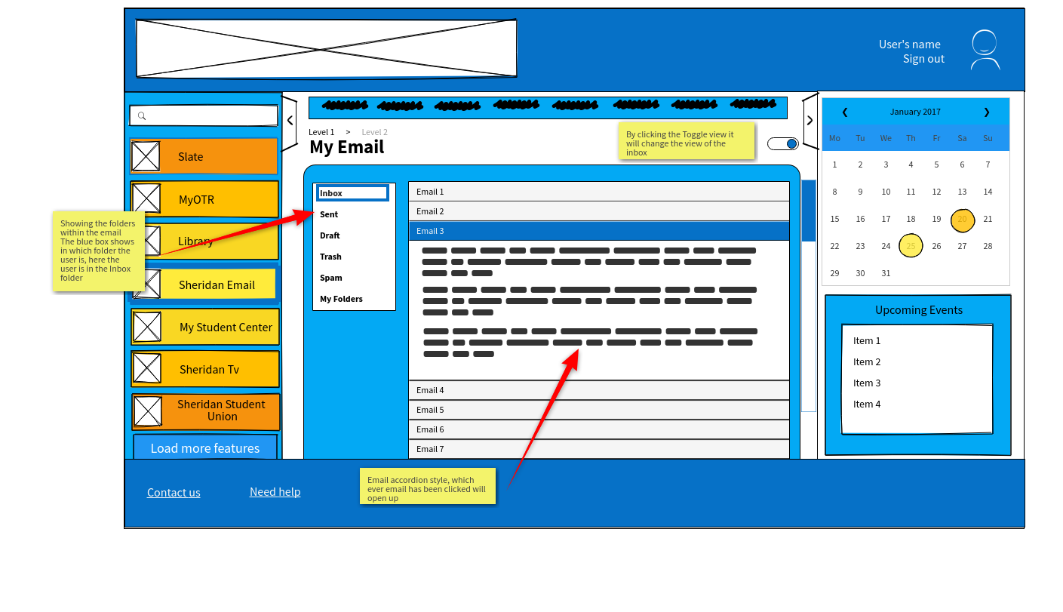
Figure 11: Wire frame for our Sheridan Email page (wireframe pro)

- Sheridan Student Union Page
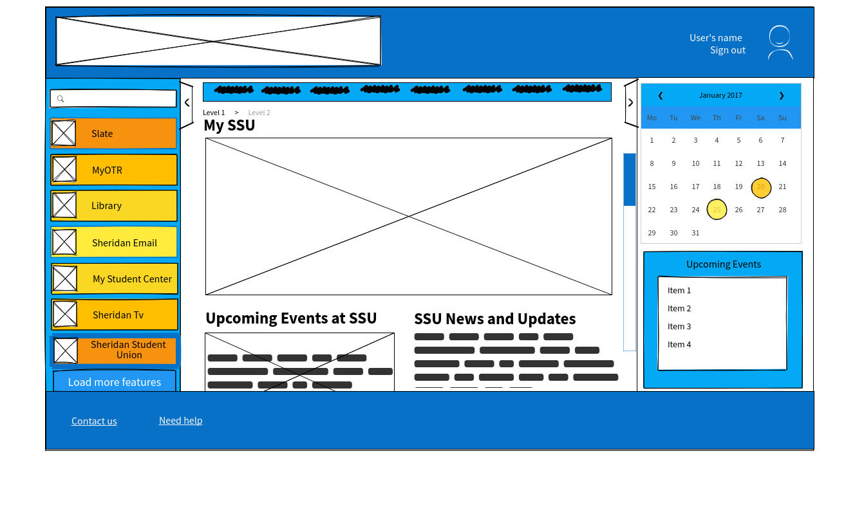
Figure 12: Wire frame for our Sheridan Student Union page (wireframe pro)

- Library Services Page
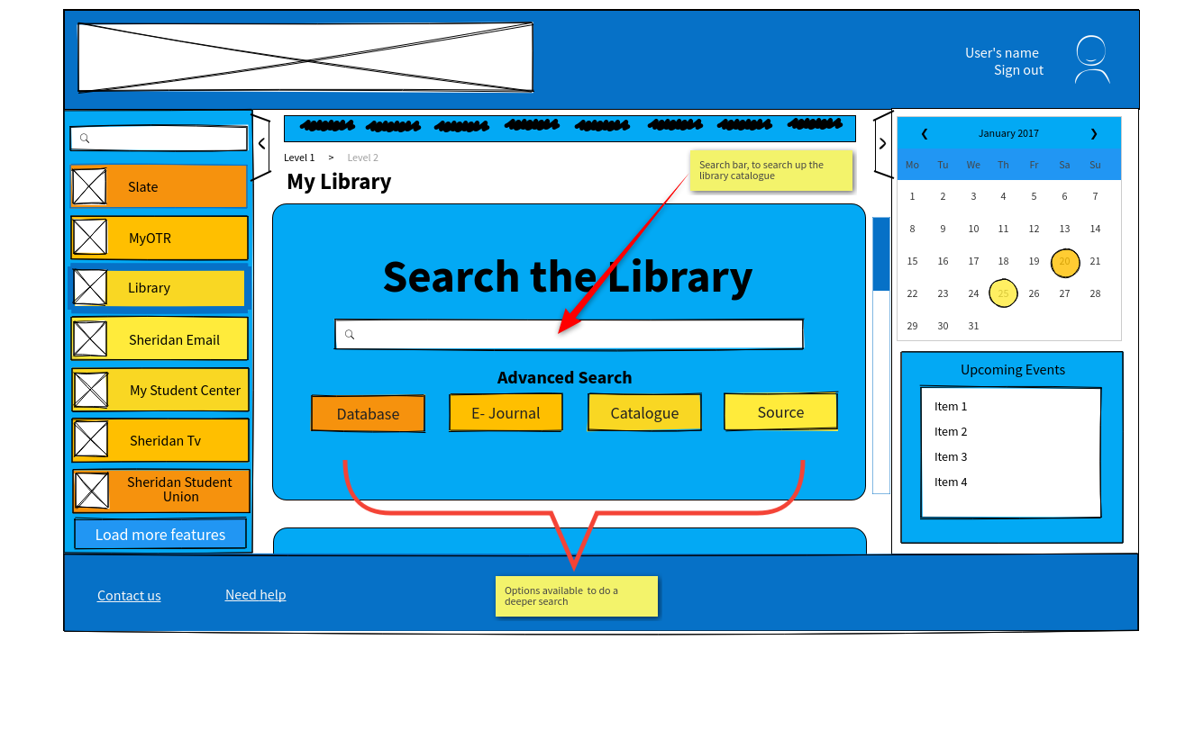
Figure 13: Wire frame for our Library Services page (wireframe pro)

